|  |
| --- |
| **POKOK BAHASAN 6** |
| **JAVA GRAPHICAL USER INTERFACE** |

**LEMBAR KERJA DAN TUGAS**

1. Membuat Frame

import javax.swing.*;

public class ContohFrame1 {

public static void main (String [] args) {

JFrame a1;

a1 = new JFrame("contoh frame");

a1.setDefaultCloseOperation(JFrame.EXIT_ON_CLOSE);

a1.setSize(300,300);

a1.setVisible(true);

}}

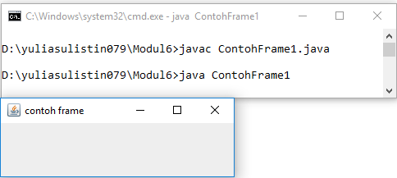

1. Membuat Dialog

import javax.swing.*;

public class Dialogku{

public static void main (String[] args){

JFrame a2;

a2 = new JFrame("frame");

a2.setDefaultCloseOperation(JFrame.EXIT_ON_CLOSE);

a2.setVisible(true);

JOptionPane.showConfirmDialog(a2,"Contoh Dialog","UMSIDA KAMPUSKU",

JOptionPane.OK_CANCEL_OPTION, JOptionPane.QUESTION_MESSAGE);

} }

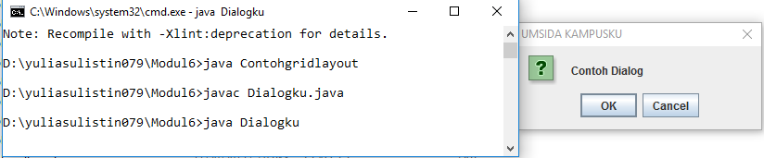

1. Membuat GridLayout

import javax.swing.*;

import java.awt.*;

public class Contohgridlayout {

public static void main (String[] args) {

JFrame frame = new JFrame ("UMSIDA KAMPUSKU");

GridLayout layout = new GridLayout (3,2);

layout.setHgap(5);

layout.setVgap(10);

frame.getContentPane().setLayout(layout);

JButton btn1 = new JButton("pencet 1");

JButton btn2 = new JButton("pencet 2");

JButton btn3 = new JButton("pencet 3");

JButton btn4 = new JButton("pencet 4");

frame.getContentPane().add(btn1);

frame.getContentPane().add(btn2);

frame.getContentPane().add(btn3);

frame.getContentPane().add(btn4);

frame.setDefaultCloseOperation(JFrame.EXIT_ON_CLOSE);

frame.pack();

frame.show();

}

}

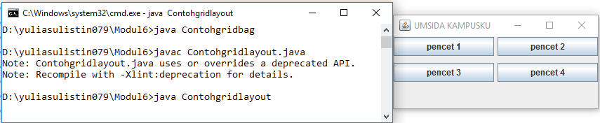

1. Membuat FlowLayout

import javax.swing.*;

import java.awt.*;

public class Contohflowlayout1 {

public static void main (String[] args) {

JFrame frame = new JFrame ("UMSIDA KAMPUSKU");

FlowLayout layout = new FlowLayout (FlowLayout.LEFT);

layout.setVgap(15);

layout.setHgap(15);

frame.getContentPane().setLayout(layout);

JButton btn1 = new JButton("Umsida 1");

JButton btn2 = new JButton("Umsida 2");

JButton btn3 = new JButton("Umsida 3");

JButton btn4 = new JButton("Umsida 4");

frame.getContentPane().add(btn1);

frame.getContentPane().add(btn2);

frame.getContentPane().add(btn3);

frame.getContentPane().add(btn4);

frame.setDefaultCloseOperation(JFrame.EXIT_ON_CLOSE);

frame.setSize(300,300);

frame.show();

}

}

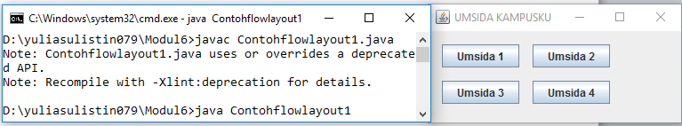

1. Membuat border

import javax.swing.*;

import java.awt.*;

public class Contohborder {

public static void main (String[] args) {

JFrame frame = new JFrame ("Contoh Border Layout");

BorderLayout layout = new BorderLayout(1,1);

frame.getContentPane().setLayout(layout);

JButton btnNorth = new JButton("NORTH");

JButton btnSouth = new JButton("SOUTH");

JButton btnEast = new JButton("EAST");

JButton btnWest = new JButton("WEST");

JButton btnCenter = new JButton("CENTER");

frame.getContentPane().add(btnNorth,BorderLayout.NORTH);

frame.getContentPane().add(btnSouth,BorderLayout.SOUTH);

frame.getContentPane().add(btnEast,BorderLayout.EAST);

frame.getContentPane().add(btnWest,BorderLayout.WEST);

frame.getContentPane().add(btnCenter,BorderLayout.CENTER);

frame.setDefaultCloseOperation(JFrame.EXIT_ON_CLOSE);

frame.pack();

frame.show();

}

}

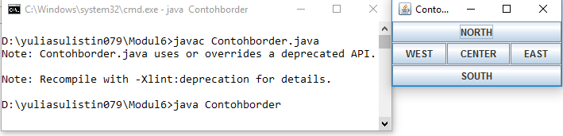

1. Membuat CardLayout

import javax.swing.*;

import java.awt.*;

public class Contohcardlayout {

public static void main (String[] args) {

JFrame frame = new JFrame ("UMSIDA KAMPUSKU");

JPanel panel1 = new JPanel();

JPanel panel2 = new JPanel();

JPanel panel3 = new JPanel();

JButton btn1 = new JButton("Tombol Umsida1");

JButton btn2 = new JButton("Tombol Umsida2");

JButton btn3 = new JButton("Tombol Umsida3");

panel1.add(btn1);

panel2.add(btn2);

panel3.add(btn3);

JTabbedPane tab = new JTabbedPane ();

tab.add(panel1,"sisi 1");

tab.add(panel2,"sisi 2");

tab.add(panel3,"sisi 3");

frame.getContentPane().add(tab,BorderLayout.NORTH);

frame.setDefaultCloseOperation(JFrame.EXIT_ON_CLOSE);

frame.setSize(300,150);

frame.show();

}}

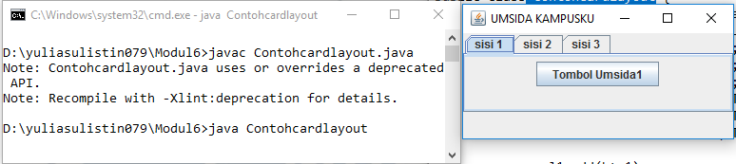

1. Membuat GridBagLayout

import javax.swing.*;

import java.awt.*;

public class Contohgridbag {

public static void main (String[] args) {

JFrame frame = new JFrame ("Contoh GridBagLayout UMSIDA");

GridBagLayout layout = new GridBagLayout();

GridBagConstraints c = new GridBagConstraints();

frame.getContentPane().setLayout(layout);

c.fill = GridBagConstraints.HORIZONTAL;

JButton btn1 = new JButton("Tombol Umsida 1");

c.weightx = 0.5;

c.gridx = 0;

c.gridy = 0;

layout.setConstraints(btn1,c);

frame.getContentPane().add(btn1);

JButton btn2 = new JButton("Tombol Umsida 2");

c.gridx = 1;

c.gridy = 0;

layout.setConstraints(btn2,c);

frame.getContentPane().add(btn2);

JButton btn3 = new JButton("Tombol Umsida 3");

c.ipady = 30;

c.gridwidth = 2;

c.gridx = 0;

c.gridy = 1;

layout.setConstraints(btn3,c);

frame.getContentPane().add(btn3);

JButton btn4 = new JButton("Tombol Umsida 4");

c.ipady = 50;

c.gridwidth = 1;

c.gridx = 0;

c.gridy = 2;

layout.setConstraints(btn4,c);

frame.getContentPane().add(btn4);

JButton btn5 = new JButton("Tombol Umsida 5");

c.ipady = 0;

c.gridwidth = 1;

c.gridx = 1;

c.gridy = 2;

c.insets = new Insets(10,0,0,0); //t,l,b,r

c.anchor = GridBagConstraints.SOUTH;

layout.setConstraints(btn5,c);

frame.getContentPane().add(btn5);

frame.setDefaultCloseOperation(JFrame.EXIT_ON_CLOSE);

frame.pack();

frame.show();

}

}

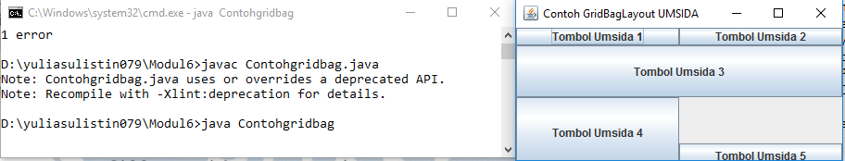

1. Membuat BoxLayout

import javax.swing.*;

import java.awt.*;

public class Contohboxlayout {

public static void main (String[] args) {

JFrame frame = new JFrame ("Box Layout");

Box comp = new Box(BoxLayout.X_AXIS);

GridBagLayout layout = new GridBagLayout();

GridBagConstraints c = new GridBagConstraints();

frame.getContentPane().setLayout(layout);

c.fill = GridBagConstraints.HORIZONTAL;

JButton btn1 = new JButton("POsisi 1");

JButton btn2 = new JButton("Posisi 2");

JButton btn3 = new JButton("Posisi 3");

JButton btn4 = new JButton("Posisi 4");

JButton btn5 = new JButton("Posisi 5");

comp.add(btn1);

comp.add(btn2);

comp.add(btn3);

comp.add(btn4);

comp.add(btn5);

frame.getContentPane().add(comp);

frame.setDefaultCloseOperation(JFrame.EXIT_ON_CLOSE);

frame.pack();

frame.show();

} }

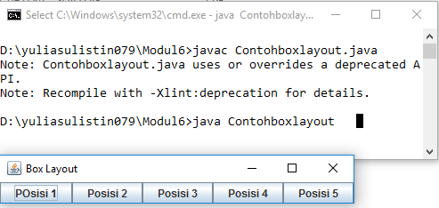

**TUGAS**

Buatlah project dengan adanya textfield sebagai inputan nim, nama, dan alamat. Dan tambahkan button ok dan cancel.

import javax.swing.*;

import java.awt.*;

public class Tugas1{

public static void main(String [] args){

Button Tombol1;

Button Tombol2;

Label Label1;

Label Label2;

Label Label3;

TextField txt1;

TextField txt2;

TextField txt3;

JFrame frame= new JFrame("Project 2");

FlowLayout layout = new FlowLayout(FlowLayout.LEFT);

layout.setHgap(15);

layout.setVgap(15);

frame.getContentPane().setLayout(layout);

Label1 = new Label("Nim :");

frame.getContentPane().add(Label1);

txt1 = new TextField("Inputkan Nim ");

frame.getContentPane().add(txt1);

Label2 = new Label("Nama :");

frame.getContentPane().add(Label2);

txt2 = new TextField("Inputkan Nama ");

frame.getContentPane().add(txt2);

Label3 = new Label("Alamat :");

frame.getContentPane().add(Label3);

txt3 = new TextField("Inputkan Alamat");

frame.getContentPane().add(txt3);

Tombol1 = new Button(" Ok ");

frame.getContentPane().add(Tombol1);

Tombol2 = new Button(" Cancel ");

frame.getContentPane().add(Tombol2);

frame.setDefaultCloseOperation(JFrame.EXIT_ON_CLOSE);

frame.setSize(280,250);

frame.show();

}}

